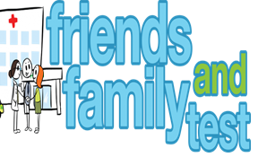
HAVE YOUR SAY TO IMPROVE YOUR CARE!
COMPLETE OUR SHORT QUESTIONNAIRE ON HOW LIKELY YOU ARE TO RECOMMEND OUR SURGERY TO FAMILY AND FRIENDS.
We have been collecting your replies and below are our results for December 22
Very Good | Good | Neither Good/nor poor | Poor | Very Poor | Don’t Know
9 | 1 | 1 | 0 | 0 | 0

Recent comments:
- All staff very helpful, doctors excellent
- Lovely staff great GP’s.
- Very fortunate to get face to face appointments
- Always treated with respect and empathy
- Never experienced any problems ever!

